Wireframe Rental Bike share

Demand Prediction

Done By : MD RIAN UR RAHAMAN

Contents

Abstract

1. WebInterface
   1. LandingPage
   2. PredictorPage
2. UserInput
3. ResultPage

Abstract

Bike sharing systems are a new generation of traditional bike rentals where the whole process from membership, rental and return back has become automatic. Through these systems, users are able to easily rent a bike from a particular position and return back at another position. Currently, there are about over 500 bike-sharing programs around the world which is composed of over 500 thousand bicycles. Today, there exists great interest in these systems due to their important role in traffic, environmental and health issues. Apart from interesting real-world applications of bike sharing systems, the characteristics of data being generated by these systems make them attractive for the research.

The most important problem from a business point of view for bike-sharing systems like Capital Bikeshare (one of the U.S.A.’s largest bicycle sharing systems) is to predict the bike demand on any particular day. There is a possibility that bike stations can be full or empty when a traveler comes to the station. While having excess bikes results in wastage of resources (bike maintenance and land/bike stand required for parking and security), having fewer bikes leads to revenue loss (ranging from a short term loss due to missing out on immediate customers to potential longer term loss due to loss in future customer base). Thus having an estimate on the demands would enable efficient functioning of this company Capital Bikeshare. And to predict the use of such a system can be helpful for the users to plan their travels and also for the Capital Bikeshare entrepreneurs to set up the system properly.

1. **Web Interface**

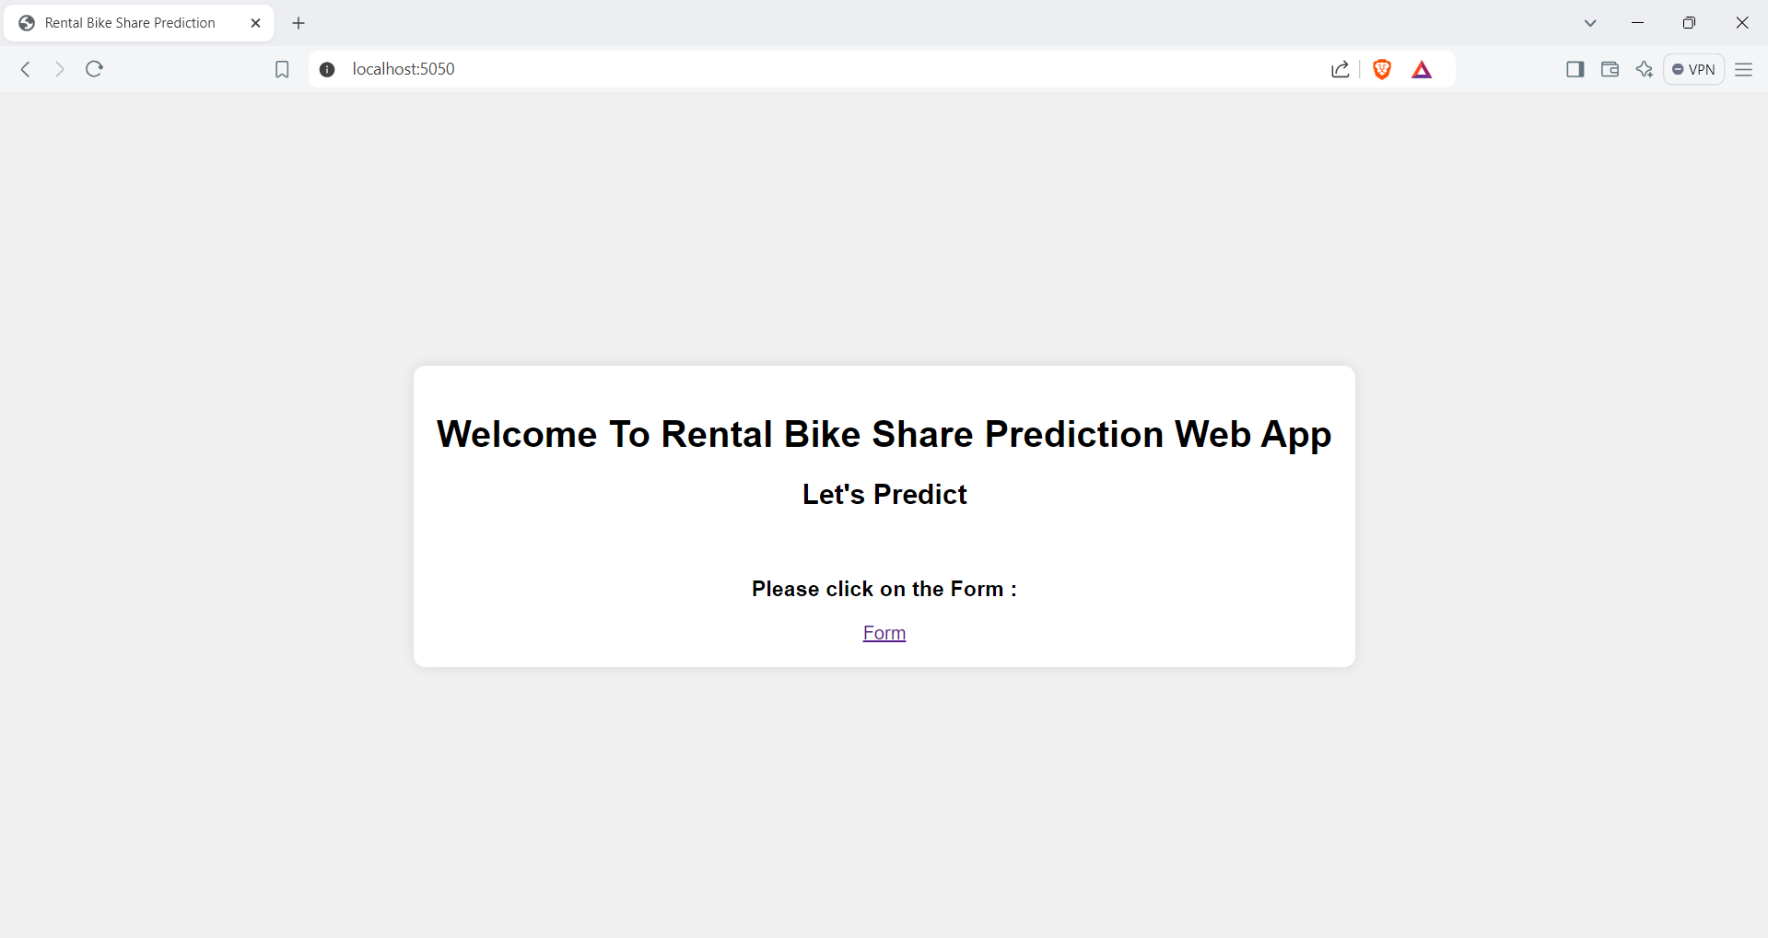

1. **Predictor Web Page :**

**After clicking the FORM button this interface will come and we can put values from the dataset and make prediction of rental bikes .**

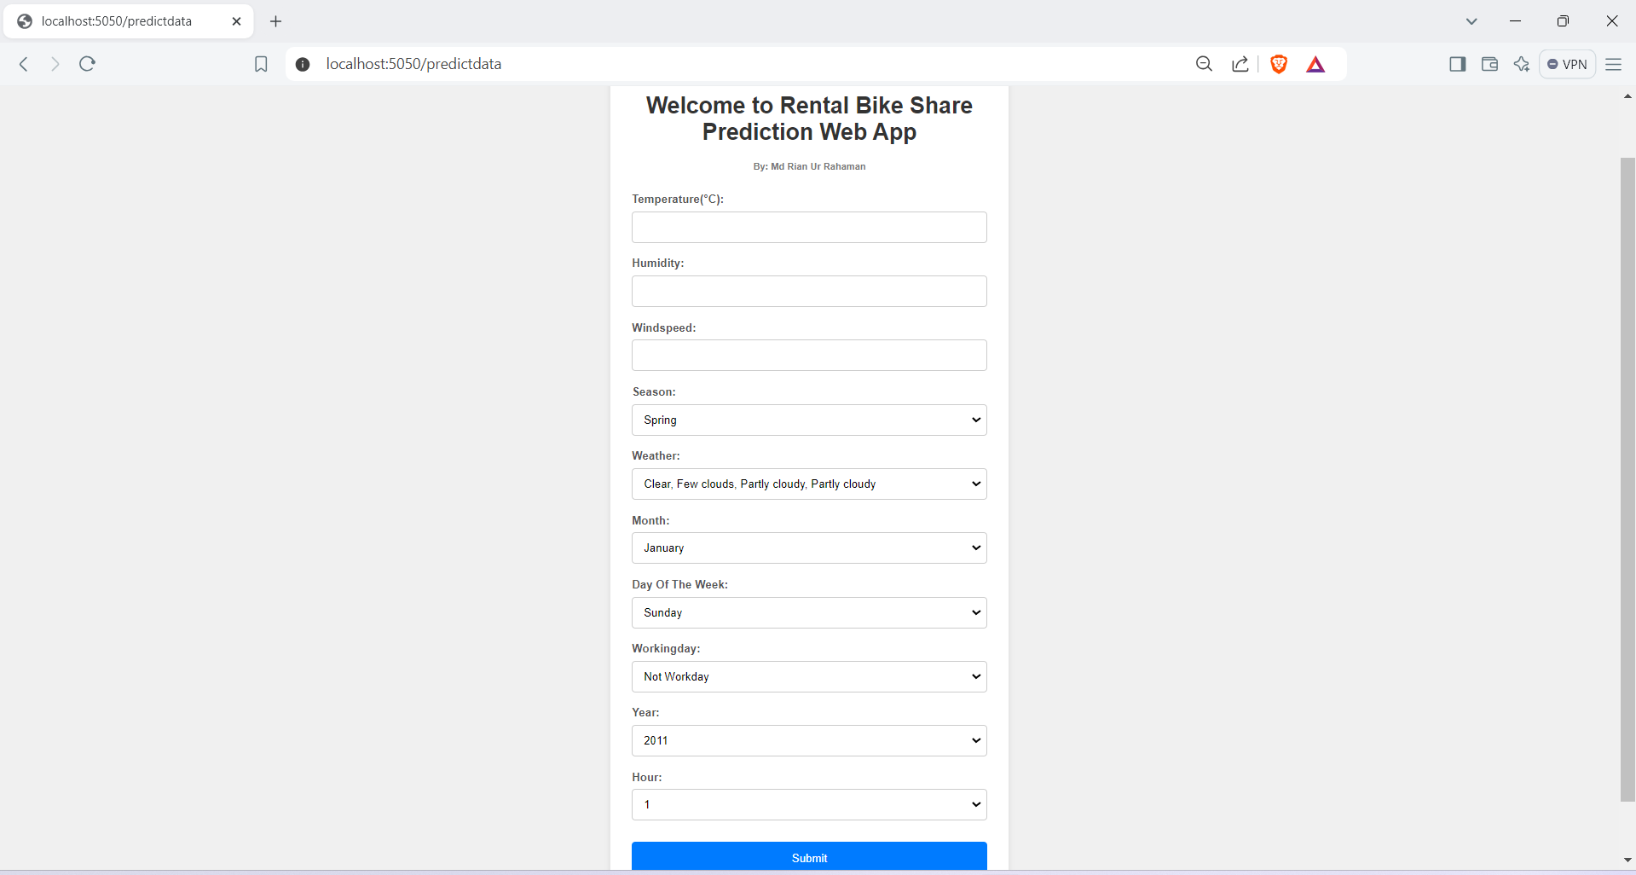

**3.User Inputs :**

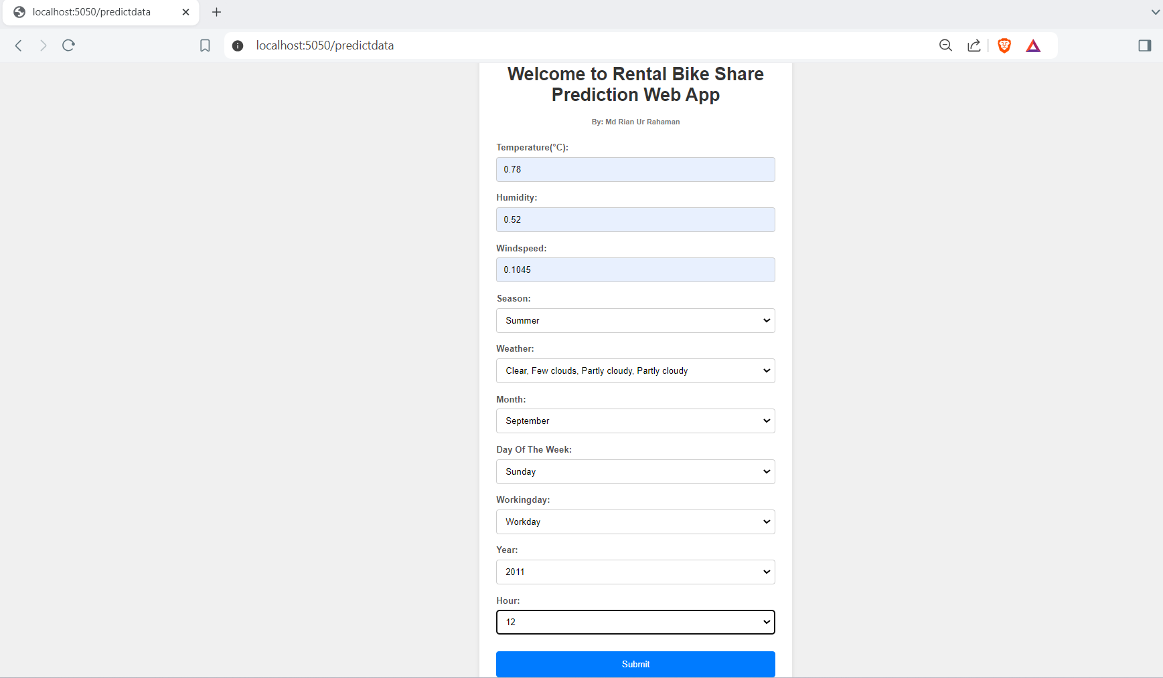

1. **Result Page :**

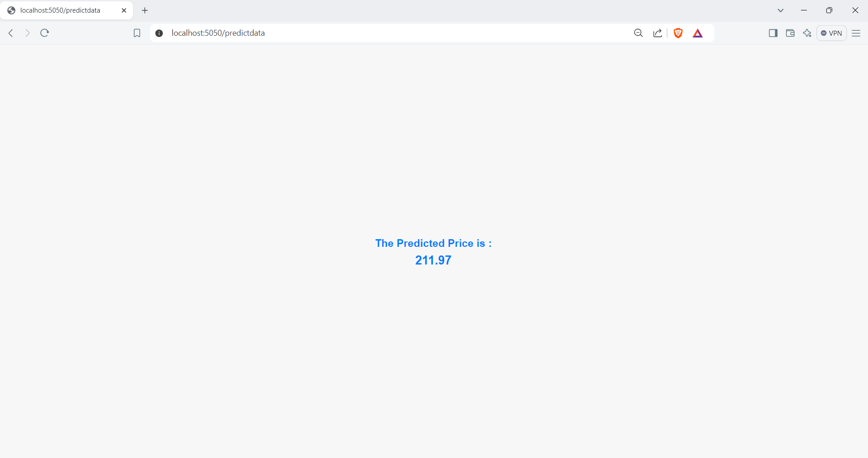

**THANK YOU**